P2V SOP

Run the VMware converter from the Local Machine which we are trying to convert or from any Jump Host which is in Domain.

It is recommended to create a Test Admin Account and provide full access and Run the Converter.

Select the attributes as required (This Local Machine) if you are trying to Run from same machine.

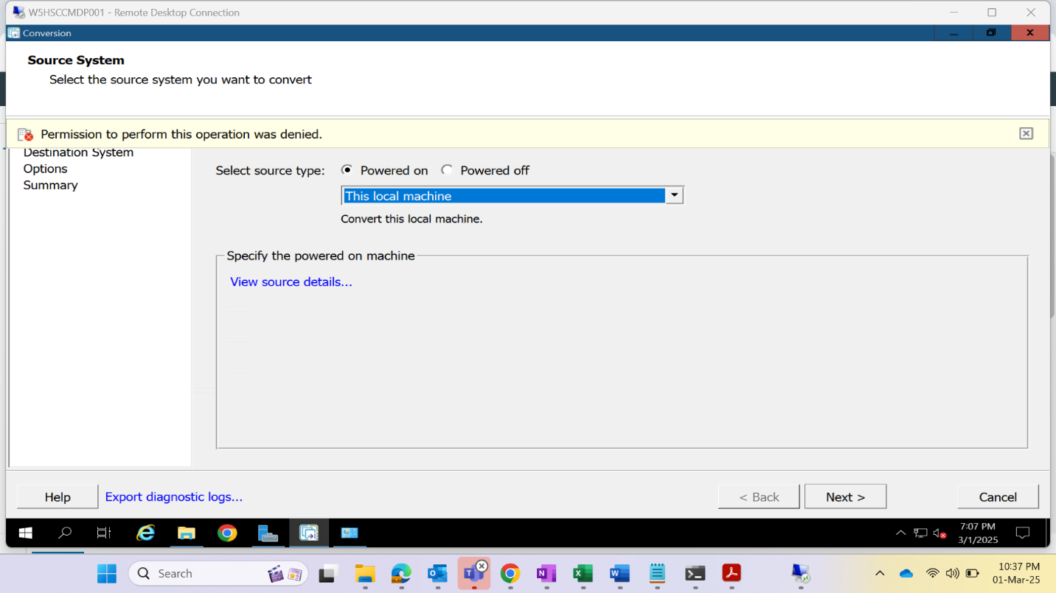

Provide the Vcenter (on which new P2V converted VM is going to be added) details as below and sign in with your sadm account.

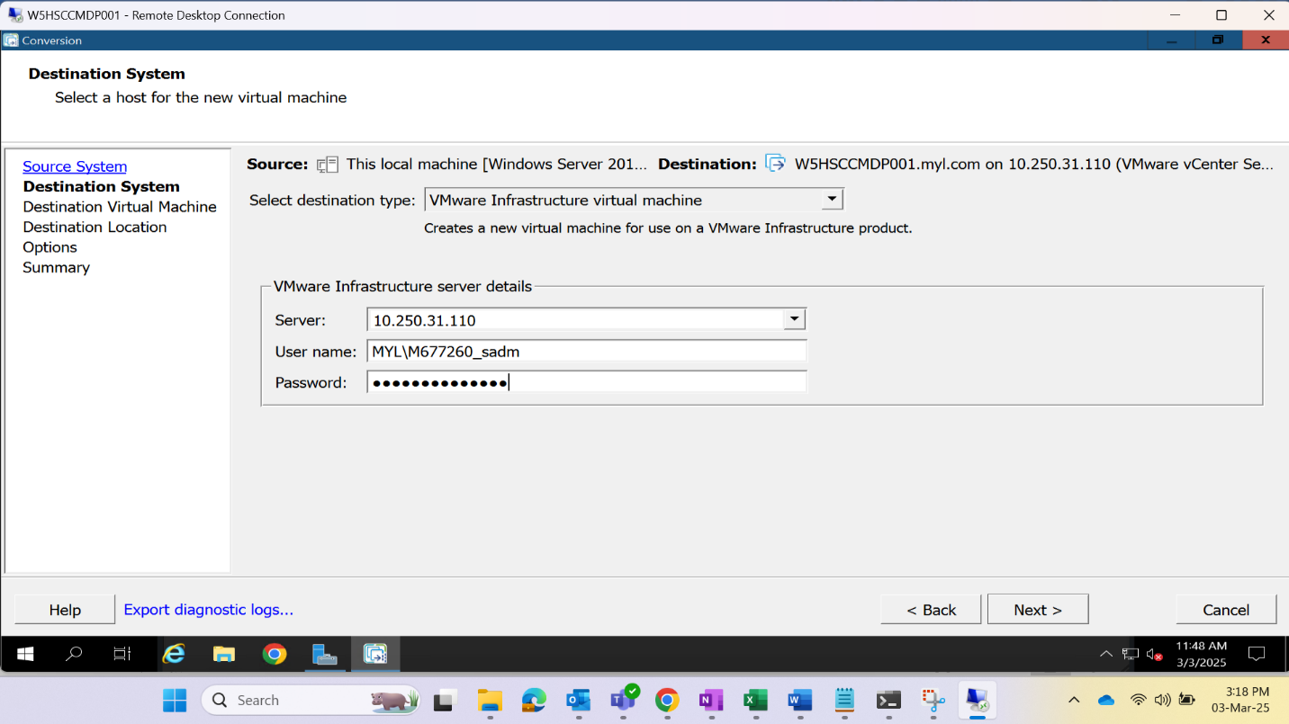

Provide all Destination details like VHost Cluster, ESXi, Folder etc.

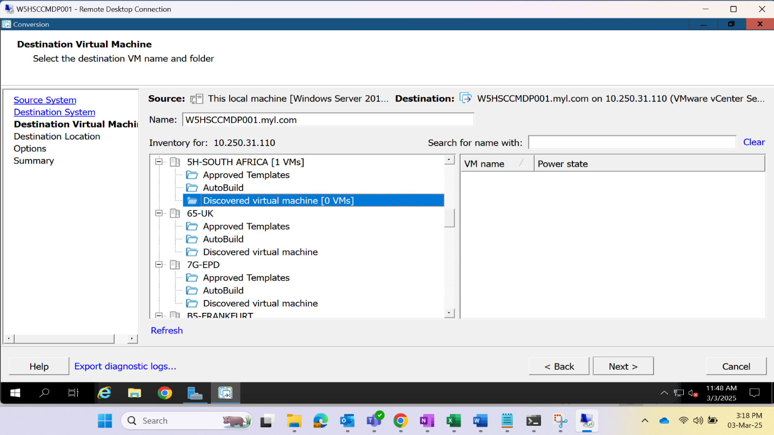

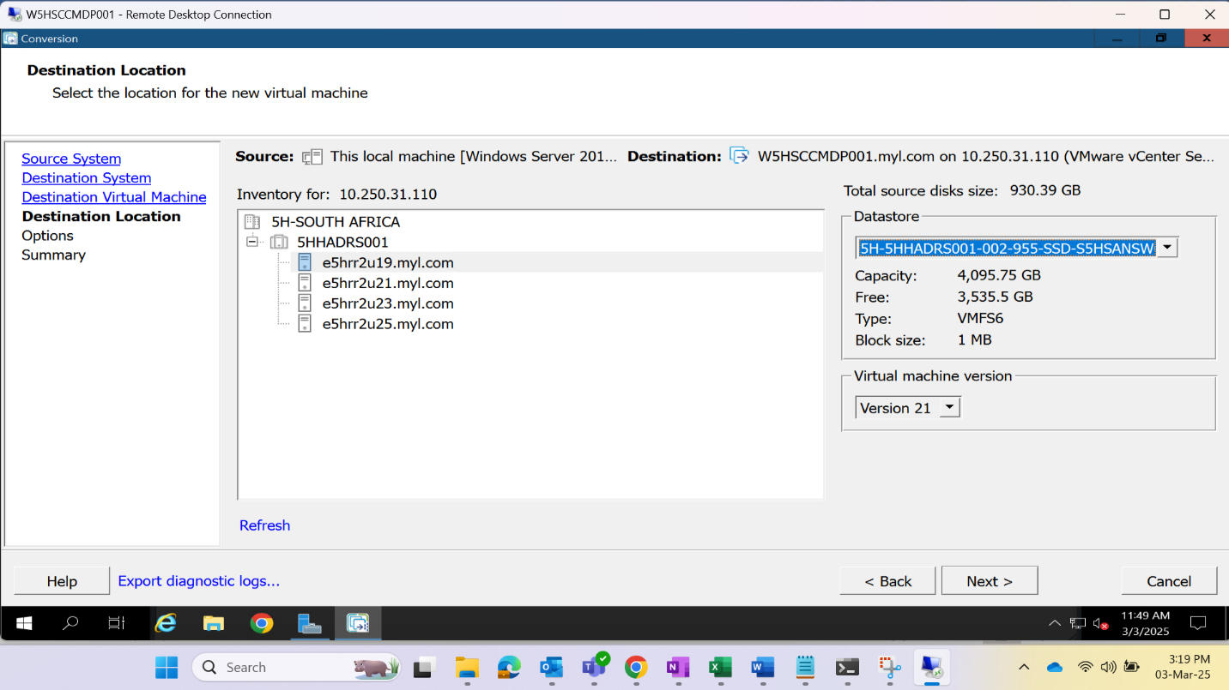

Set the Folder capacity and the vmdk files as per the requirement on the Destination server.

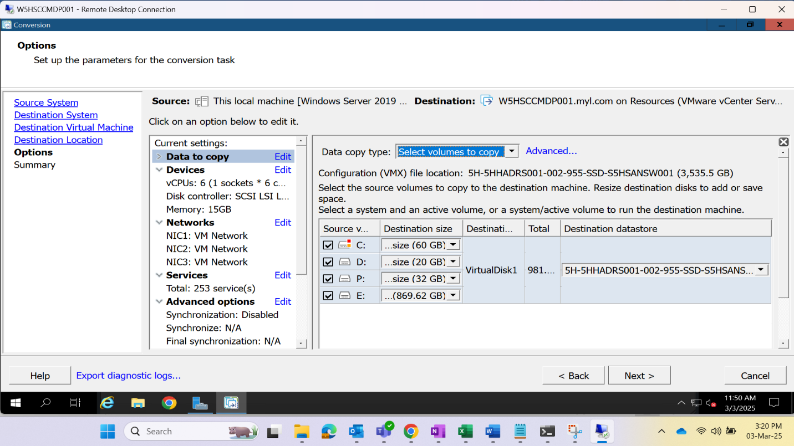

Verify all the provided details  
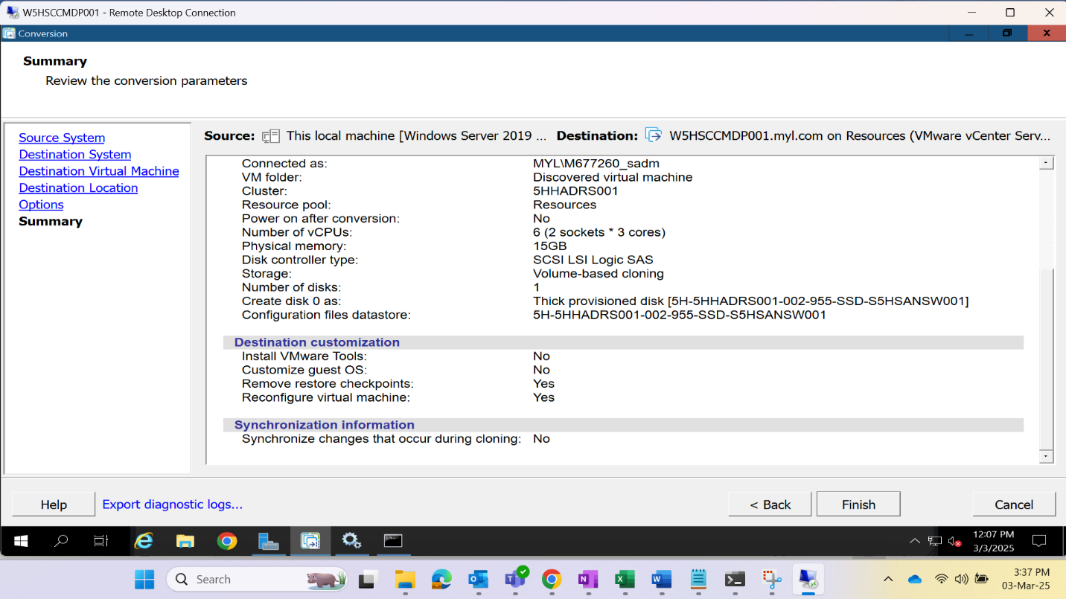

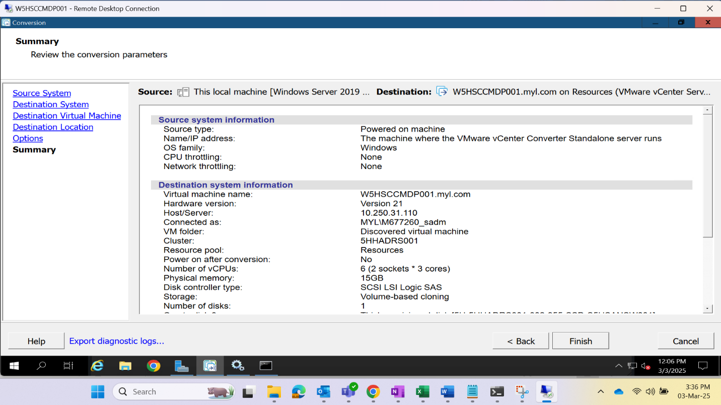

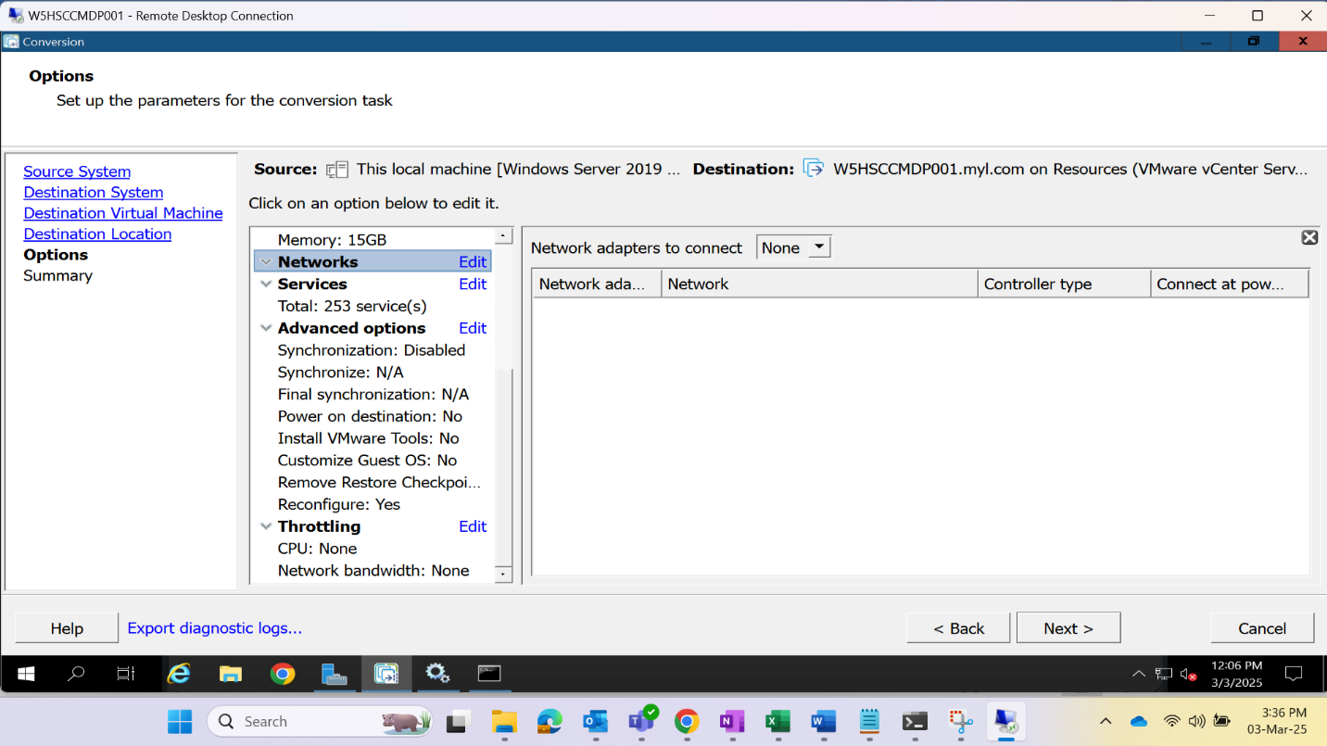

Click on Submit once all the provided inputs are verified.

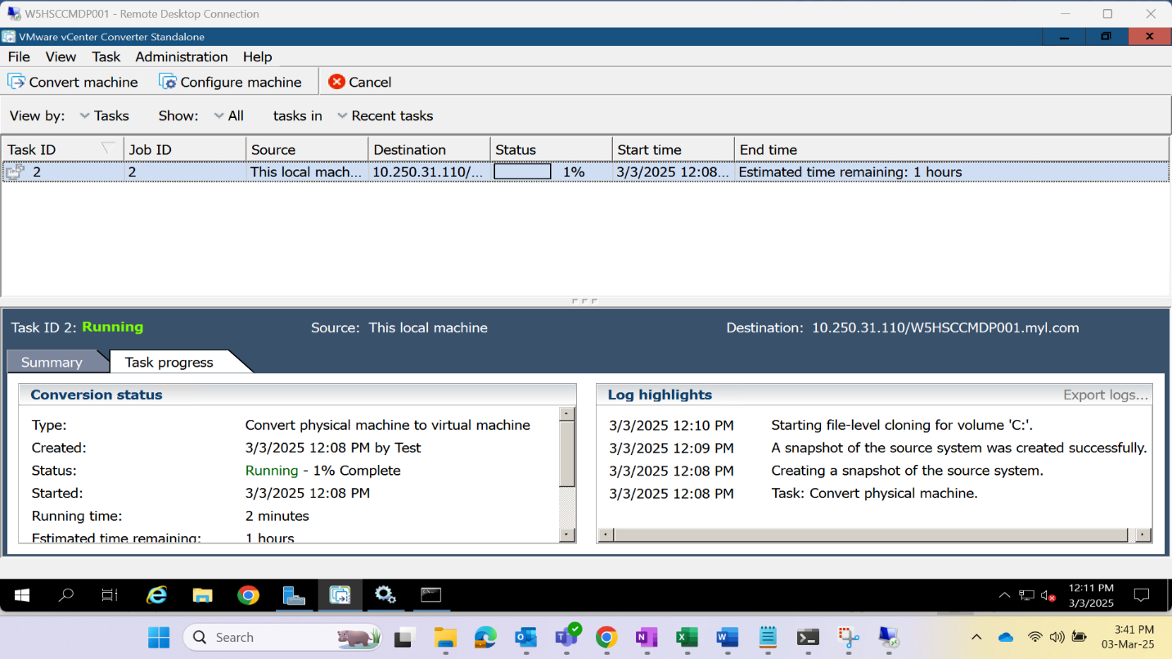

The conversion will start and the VM gets created once the status is completed.

Perform all the required Changes on the Destination server.

Use Temp-Ip

